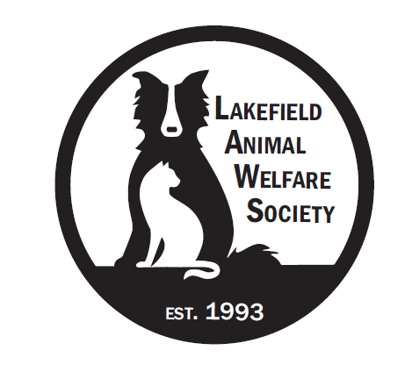
LAKEFIELD ANIMAL WELFARE SOCIETY

2026 ANNUAL GENERAL MEETING

Notice is hereby given the Annual General Meeting of the Lakefield Animal Welfare Society to be held in person at River Den, Lakefield and via Zoom on Wednesday, June 17, 2025, at 6:00 pm.

- Members: Registration via email or phone – prior to meeting.
- Call to Order
- Land acknowledgement
- Report on the notice calling the meeting.
- Quorum: Attendance report
- Minutes: Minutes of 2025 AGM – for approval.
- Introduction by Lyndsay Lisson-De Ell for Dr. Kathleen Norman
- Keynote Speaker – Dr. Kathleen Norman
- Introduction by Linda Twohey, Treasurer of Patricia Hoyt and Andrew Hauraney of Baker Tilley
- Financial Statements: Patricia Hoyt and Andrew Hauraney of Baker Tilley - Auditing, considering and approving the Financial Statements of the corporation for the fiscal year ended December 31, 2025, together with the audited financial statement. Presentation of the Corporation’s audited 2025 Financial Statements.
- Board’s Report by Chair: Marilyn Strain to give an overview of the 2025 year.
- Shelter Report by Lyndsay Lisson-De Ell, Director of Operations: Report on shelter operations, animal rescue, rehabilitation and adoptions.
- Awards and Tributes
- Business of the Meeting:
  - a) Approve the 2025 audited Financial Statements
  - b) Ratifying all the acts of the Board of Directors of the Corporation that have been carried out
  - and recorded in the official minutes.
  - c) Appoint the Auditor of the Corporation for the upcoming year.
  - d) Election of Directors for the new term. Introduction of new Director Dan Moloney.
- Open Forum for Members: Questions or Comments via Zoom chat.
- Motion to adjourn.

Dated at Lakefield, Ontario this 6th day of June, 2026

LAWS Board of Directors

